# **Name: Abdurrahman Qureshi**

# **Roll No: 242466**

Practical No: 8

1) Write a program to demonstrate GUI of a Login page using JAVA

LOGIN PAGE

import javax.swing.*;  
import java.awt.*;  
import java.awt.event.ActionEvent;  
import java.awt.event.ActionListener;  
  
public class LoginPage extends JFrame {  
  
 *// Components for the login page* private JLabel labelUsername, labelPassword;  
 private JTextField textFieldUsername;  
 private JPasswordField passwordField;  
 private JButton buttonLogin, buttonReset;  
  
 public LoginPage() {  
 *// Setting up the JFrame* setTitle("Login Page");  
 setSize(350, 200);  
 setDefaultCloseOperation(JFrame.*EXIT_ON_CLOSE*);  
 setLocationRelativeTo(null); *// Center the frame  
  
 // Initialize components* labelUsername = new JLabel("Username:");  
 labelPassword = new JLabel("Password:");  
 textFieldUsername = new JTextField(15);  
 passwordField = new JPasswordField(15);  
 buttonLogin = new JButton("Login");  
 buttonReset = new JButton("Reset");  
  
 *// Set layout manager* setLayout(new GridBagLayout());  
 GridBagConstraints gbc = new GridBagConstraints();  
 gbc.insets = new Insets(5, 5, 5, 5); *// Padding around components  
  
 // Add components to the JFrame* gbc.gridx = 0; *// column 0* gbc.gridy = 0; *// row 0* add(labelUsername, gbc);  
  
 gbc.gridx = 1;  
 add(textFieldUsername, gbc);  
  
 gbc.gridx = 0;  
 gbc.gridy = 1;  
 add(labelPassword, gbc);  
  
 gbc.gridx = 1;  
 add(passwordField, gbc);  
  
 gbc.gridx = 0;  
 gbc.gridy = 2;  
 add(buttonLogin, gbc);  
  
 gbc.gridx = 1;  
 add(buttonReset, gbc);  
  
 *// Button action listeners* buttonLogin.addActionListener(new ActionListener() {  
 @Override  
 public void actionPerformed(ActionEvent e) {  
 String username = textFieldUsername.getText();  
 String password = new String(passwordField.getPassword());  
  
 *// Basic username/password check* if (username.equals("admin") && password.equals("1234")) {  
 JOptionPane.*showMessageDialog*(null, "Login Successful!");  
 } else {  
 JOptionPane.*showMessageDialog*(null, "Invalid Username or Password", "Error", JOptionPane.*ERROR_MESSAGE*);  
 }  
 }  
 });  
  
 buttonReset.addActionListener(new ActionListener() {  
 @Override  
 public void actionPerformed(ActionEvent e) {  
 *// Clear the text fields* textFieldUsername.setText("");  
 passwordField.setText("");  
 }  
 });  
 }  
  
 public static void main(String[] args) {  
 *// Run the login page* SwingUtilities.*invokeLater*(new Runnable() {  
 @Override  
 public void run() {  
 new LoginPage().setVisible(true);  
 }  
 });  
 }  
}

OUTPUT

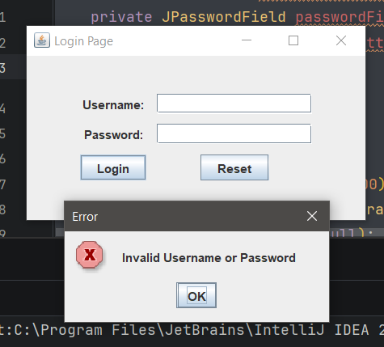 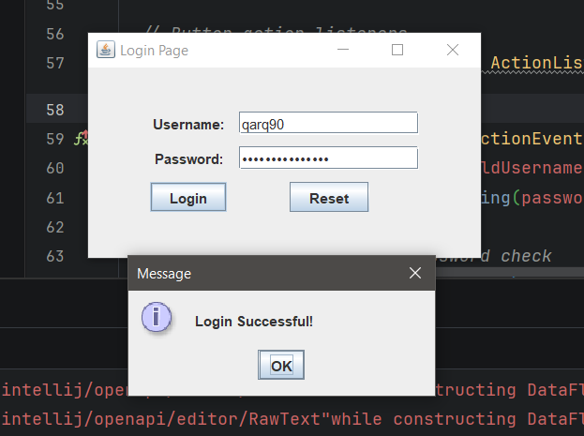

2) Write a program to demonstrate GUI of a banking application using JAVA

ADDING A CUSTOMER

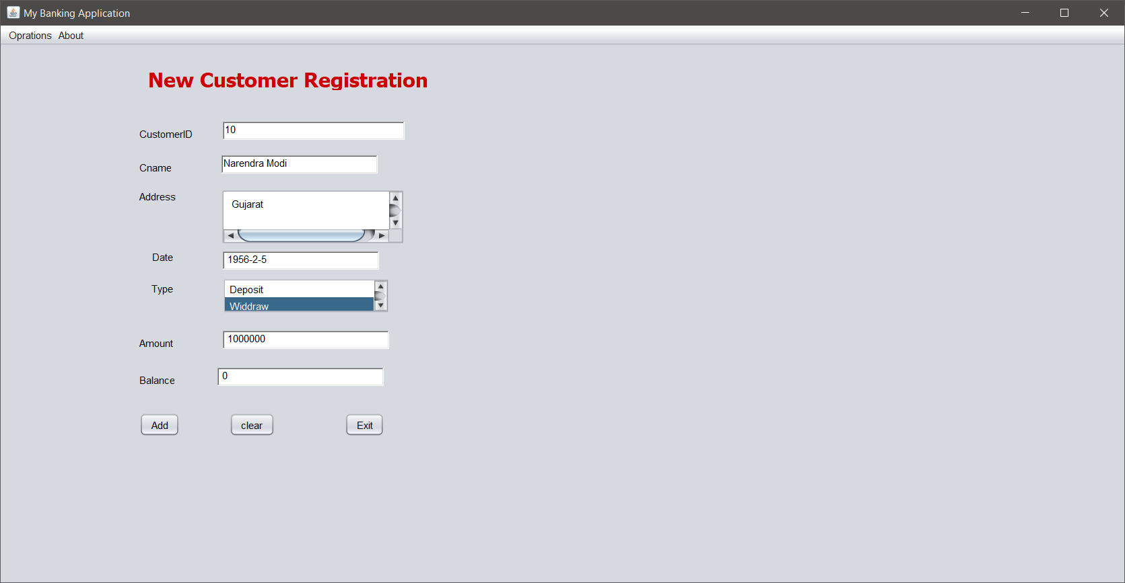

ADDING A CUSTOMER (CODE)

import javax.swing.*;

import java.awt.*;

import java.awt.event.ActionEvent;

import java.awt.event.ActionListener;

public class TransactionForm extends JPanel {

private TextField txtid, txtname, txtdate, txtamount, txtbalance;

private JTextArea txtAddress;

private JList<String> lstType;

private JButton cmdAdd, cmdClear, cmdExit;

public TransactionForm() {

// Initialize components

JLabel jLabel1 = new JLabel("CustomerID");

txtid = new TextField(20);

JLabel jLabel2 = new JLabel("Cname");

txtname = new TextField(20);

JLabel jLabel3 = new JLabel("Address");

txtAddress = new JTextArea(5, 20);

JScrollPane jScrollPane1 = new JScrollPane(txtAddress);

JLabel jLabel4 = new JLabel("Date");

txtdate = new TextField(20);

JLabel jLabel5 = new JLabel("Type");

lstType = new JList<>(new String[]{"Deposit", "Withdraw"});

JScrollPane jScrollPane2 = new JScrollPane(lstType);

JLabel jLabel6 = new JLabel("Amount");

txtamount = new TextField(20);

JLabel jLabel7 = new JLabel("Balance");

txtbalance = new TextField(20);

cmdAdd = new JButton("Add");

cmdClear = new JButton("Clear");

cmdExit = new JButton("Exit");

// Layout setup

setLayout(new GridBagLayout());

GridBagConstraints gbc = new GridBagConstraints();

gbc.fill = GridBagConstraints.HORIZONTAL;

gbc.insets = new Insets(10, 10, 10, 10);

// Row 1 - CustomerID

gbc.gridx = 0;

gbc.gridy = 0;

add(jLabel1, gbc);

gbc.gridx = 1;

gbc.gridy = 0;

add(txtid, gbc);

// Row 2 - Cname

gbc.gridx = 0;

gbc.gridy = 1;

add(jLabel2, gbc);

gbc.gridx = 1;

gbc.gridy = 1;

add(txtname, gbc);

// Row 3 - Address

gbc.gridx = 0;

gbc.gridy = 2;

add(jLabel3, gbc);

gbc.gridx = 1;

gbc.gridy = 2;

add(jScrollPane1, gbc);

// Row 4 - Date

gbc.gridx = 0;

gbc.gridy = 3;

add(jLabel4, gbc);

gbc.gridx = 1;

gbc.gridy = 3;

add(txtdate, gbc);

// Row 5 - Type

gbc.gridx = 0;

gbc.gridy = 4;

add(jLabel5, gbc);

gbc.gridx = 1;

gbc.gridy = 4;

add(jScrollPane2, gbc);

// Row 6 - Amount

gbc.gridx = 0;

gbc.gridy = 5;

add(jLabel6, gbc);

gbc.gridx = 1;

gbc.gridy = 5;

add(txtamount, gbc);

// Row 7 - Balance

gbc.gridx = 0;

gbc.gridy = 6;

add(jLabel7, gbc);

gbc.gridx = 1;

gbc.gridy = 6;

add(txtbalance, gbc);

// Row 8 - Buttons

gbc.gridx = 0;

gbc.gridy = 7;

add(cmdAdd, gbc);

gbc.gridx = 1;

gbc.gridy = 7;

add(cmdClear, gbc);

gbc.gridx = 2;

gbc.gridy = 7;

add(cmdExit, gbc);

// Button actions

cmdAdd.addActionListener(new ActionListener() {

@Override

public void actionPerformed(ActionEvent e) {

// Add button action

String id = txtid.getText();

String name = txtname.getText();

String address = txtAddress.getText();

String date = txtdate.getText();

String type = lstType.getSelectedValue();

String amount = txtamount.getText();

String balance = txtbalance.getText();

// Process transaction (to be implemented)

JOptionPane.showMessageDialog(null, "Transaction Added");

}

});

cmdClear.addActionListener(new ActionListener() {

@Override

public void actionPerformed(ActionEvent e) {

// Clear fields

txtid.setText("");

txtname.setText("");

txtAddress.setText("");

txtdate.setText("");

lstType.clearSelection();

txtamount.setText("");

txtbalance.setText("");

}

});

cmdExit.addActionListener(new ActionListener() {

@Override

public void actionPerformed(ActionEvent e) {

// Exit the application

System.exit(0);

}

});

}

public static void main(String[] args) {

JFrame frame = new JFrame("Transaction Form");

frame.setDefaultCloseOperation(JFrame.EXIT_ON_CLOSE);

frame.add(new TransactionForm());

frame.pack();

frame.setVisible(true);

}

}

AFTER INSERTING TABLE

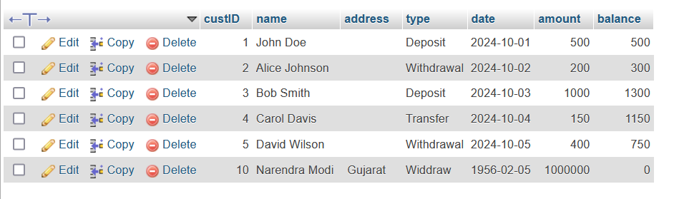

VIEWING CUSTOMERS (CODE)

import javax.swing.*;

import java.awt.*;

import java.awt.event.ActionEvent;

import java.awt.event.ActionListener;

public class CustomerDetailsForm extends JPanel {

private JLabel jLabel1, jLabel8;

private TextField txtcuid;

private JButton cmdview, jButton1, jButton2, cmdviewall;

private JTable jTable1;

private JScrollPane jScrollPane2;

public CustomerDetailsForm() {

initComponents();

}

private void initComponents() {

// Initialize components

jLabel1 = new JLabel("CustomerId");

txtcuid = new TextField();

cmdview = new JButton("ViewCustomers");

jButton1 = new JButton("Clear");

jButton2 = new JButton("Exit");

cmdviewall = new JButton("ViewAll");

jLabel8 = new JLabel("View Customer Details");

jLabel8.setFont(new Font("Tahoma", Font.BOLD, 24));

jLabel8.setForeground(new Color(204, 0, 0)); // #cc0000 color

// Table setup

String[] columnNames = {"Title 1", "Title 2", "Title 3", "Title 4"};

Object[][] data = new Object[4][4]; // Empty table with 4 rows and 4 columns

jTable1 = new JTable(data, columnNames);

jScrollPane2 = new JScrollPane(jTable1);

// Layout setup (using GroupLayout)

GroupLayout layout = new GroupLayout(this);

this.setLayout(layout);

layout.setAutoCreateGaps(true);

layout.setAutoCreateContainerGaps(true);

layout.setHorizontalGroup(

layout.createParallelGroup(GroupLayout.Alignment.LEADING)

.addGroup(layout.createSequentialGroup()

.addGap(36)

.addComponent(jLabel8)

.addGap(36))

.addGroup(layout.createSequentialGroup()

.addGap(36)

.addComponent(jLabel1)

.addComponent(txtcuid, GroupLayout.PREFERRED_SIZE, 138, GroupLayout.PREFERRED_SIZE)

.addGap(36))

.addGroup(layout.createSequentialGroup()

.addComponent(jScrollPane2, GroupLayout.PREFERRED_SIZE, 584, GroupLayout.PREFERRED_SIZE)

.addGap(46))

.addGroup(layout.createSequentialGroup()

.addComponent(cmdview)

.addGap(31)

.addComponent(jButton1)

.addGap(53)

.addComponent(cmdviewall)

.addGap(75)

.addComponent(jButton2))

);

layout.setVerticalGroup(

layout.createSequentialGroup()

.addGap(36)

.addComponent(jLabel8)

.addGap(36)

.addGroup(layout.createParallelGroup(GroupLayout.Alignment.BASELINE)

.addComponent(jLabel1)

.addComponent(txtcuid, GroupLayout.PREFERRED_SIZE, GroupLayout.DEFAULT_SIZE, GroupLayout.PREFERRED_SIZE))

.addGap(33)

.addComponent(jScrollPane2, GroupLayout.PREFERRED_SIZE, 100, GroupLayout.PREFERRED_SIZE)

.addGap(46)

.addGroup(layout.createParallelGroup(GroupLayout.Alignment.BASELINE)

.addComponent(cmdview)

.addComponent(jButton1)

.addComponent(cmdviewall)

.addComponent(jButton2))

.addGap(81)

);

// Button actions

cmdview.addActionListener(new ActionListener() {

public void actionPerformed(ActionEvent evt) {

cmdviewActionPerformed(evt);

}

});

jButton1.addActionListener(new ActionListener() {

public void actionPerformed(ActionEvent evt) {

jButton1ActionPerformed(evt);

}

});

jButton2.addActionListener(new ActionListener() {

public void actionPerformed(ActionEvent evt) {

jButton2ActionPerformed(evt);

}

});

cmdviewall.addActionListener(new ActionListener() {

public void actionPerformed(ActionEvent evt) {

cmdviewallActionPerformed(evt);

}

});

}

// Action Listeners

private void cmdviewActionPerformed(ActionEvent evt) {

// Code to view specific customer details based on txtcuid input

String customerId = txtcuid.getText();

System.out.println("View Customer Details for ID: " + customerId);

}

private void jButton1ActionPerformed(ActionEvent evt) {

// Clear input fields

txtcuid.setText("");

System.out.println("Clear input fields");

}

private void jButton2ActionPerformed(ActionEvent evt) {

// Exit the application

System.exit(0);

}

private void cmdviewallActionPerformed(ActionEvent evt) {

// View all customer details

System.out.println("View All Customers");

}

public static void main(String[] args) {

JFrame frame = new JFrame("Customer Details");

frame.setDefaultCloseOperation(JFrame.EXIT_ON_CLOSE);

frame.add(new CustomerDetailsForm());

frame.pack();

frame.setLocationRelativeTo(null);

frame.setVisible(true);

}

}

VIEWING CUSTOMERS

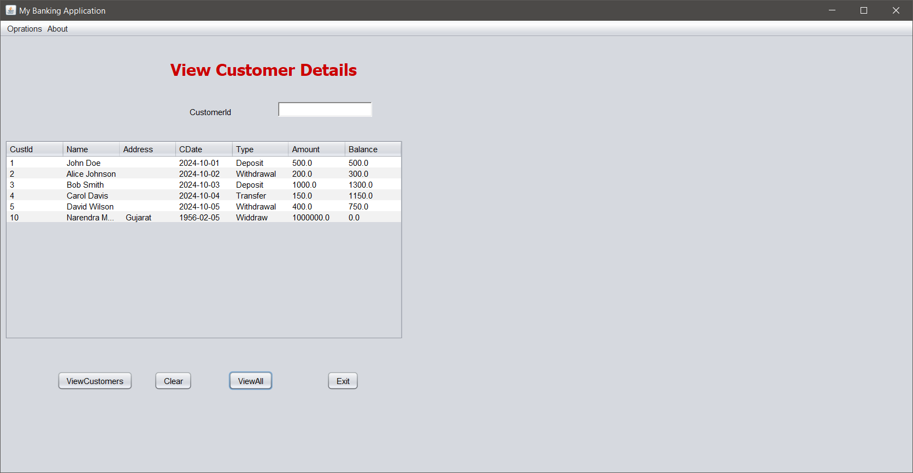

VIEWING CUSTOMER WITH ID 2

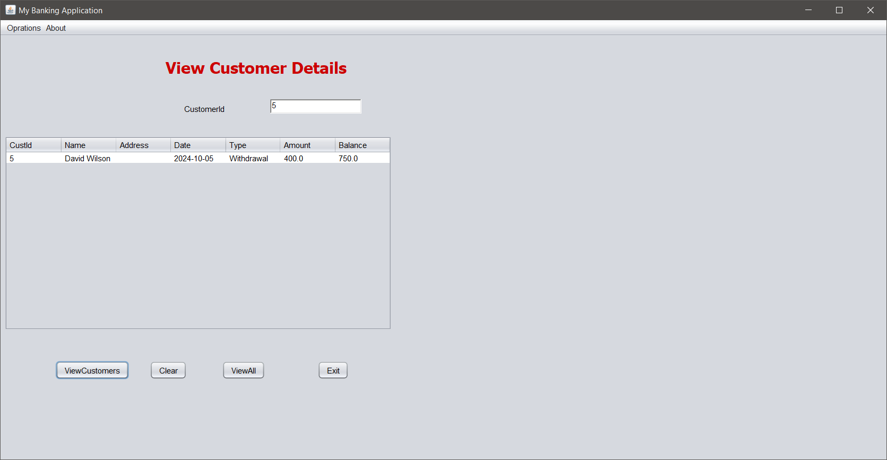

VIEWING CUSTOMERS’S BALANCE

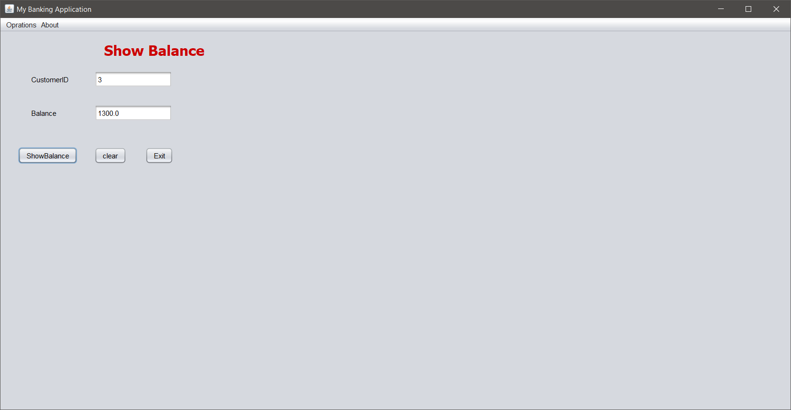

VIEWING CUSTOMERS’S BALANCE (CODE)

import javax.swing.*;

import javax.swing.table.DefaultTableModel;

import java.awt.*;

import java.awt.event.ActionEvent;

import java.awt.event.ActionListener;

public class TransactionHistoryPanel extends JPanel {

private JLabel jLabel1;

private JLabel jLabel2;

private CalendarPane calendarPane2;

private CalendarPane calendarPane3;

private JButton jButton1;

private JButton jButton2;

private JScrollPane jScrollPane1;

private JTable jTable1;

private JLabel jLabel8;

public TransactionHistoryPanel() {

initComponents();

}

private void initComponents() {

// Labels

jLabel1 = new JLabel("From");

jLabel2 = new JLabel("To");

jLabel8 = new JLabel("Transaction History");

jLabel8.setFont(new Font("Tahoma", Font.BOLD, 24));

jLabel8.setForeground(new Color(204, 0, 0)); // Color: #cc0000

// Calendar panes (assuming CalendarPane is a custom class)

calendarPane2 = new CalendarPane();

calendarPane3 = new CalendarPane();

// Buttons

jButton1 = new JButton("Show History");

jButton2 = new JButton("Exit");

// Add action listeners for buttons

jButton1.addActionListener(new ActionListener() {

@Override

public void actionPerformed(ActionEvent evt) {

jButton1ActionPerformed(evt);

}

});

jButton2.addActionListener(new ActionListener() {

@Override

public void actionPerformed(ActionEvent evt) {

jButton2ActionPerformed(evt);

}

});

// Table inside JScrollPane

jTable1 = new JTable(new DefaultTableModel(

new Object[][]{

{null, null, null, null},

{null, null, null, null},

{null, null, null, null},

{null, null, null, null}

},

new String[]{

"Title 1", "Title 2", "Title 3", "Title 4"

}

));

jScrollPane1 = new JScrollPane(jTable1);

// Layout setup (uses GroupLayout for organization, similar to the XML structure)

GroupLayout layout = new GroupLayout(this);

this.setLayout(layout);

layout.setHorizontalGroup(

layout.createParallelGroup(GroupLayout.Alignment.LEADING)

.addGroup(layout.createSequentialGroup()

.addGap(42, 42, 42)

.addComponent(jLabel1)

.addPreferredGap(LayoutStyle.ComponentPlacement.RELATED, 27, Short.MAX_VALUE)

.addComponent(calendarPane2, GroupLayout.PREFERRED_SIZE, 264, GroupLayout.PREFERRED_SIZE)

.addGap(42, 42, 42)

.addComponent(jLabel2)

.addPreferredGap(LayoutStyle.ComponentPlacement.UNRELATED)

.addComponent(calendarPane3, GroupLayout.PREFERRED_SIZE, 207, GroupLayout.PREFERRED_SIZE)

.addGap(42, 42, 42))

.addGroup(layout.createSequentialGroup()

.addGap(170, 170, 170)

.addComponent(jLabel8, GroupLayout.PREFERRED_SIZE, 419, GroupLayout.PREFERRED_SIZE)

.addContainerGap(GroupLayout.DEFAULT_SIZE, Short.MAX_VALUE))

.addGroup(GroupLayout.Alignment.TRAILING, layout.createSequentialGroup()

.addContainerGap(54, Short.MAX_VALUE)

.addGroup(layout.createParallelGroup(GroupLayout.Alignment.TRAILING)

.addComponent(jScrollPane1, GroupLayout.PREFERRED_SIZE, 559, GroupLayout.PREFERRED_SIZE)

.addGroup(layout.createSequentialGroup()

.addComponent(jButton1)

.addGap(18, 18, 18)

.addComponent(jButton2)))

.addGap(54, 54, 54))

);

layout.setVerticalGroup(

layout.createParallelGroup(GroupLayout.Alignment.LEADING)

.addGroup(layout.createSequentialGroup()

.addGap(57, 57, 57)

.addGroup(layout.createParallelGroup(GroupLayout.Alignment.BASELINE)

.addComponent(jLabel1)

.addComponent(calendarPane2, GroupLayout.PREFERRED_SIZE, 181, GroupLayout.PREFERRED_SIZE)

.addComponent(jLabel2)

.addComponent(calendarPane3, GroupLayout.PREFERRED_SIZE, 174, GroupLayout.PREFERRED_SIZE))

.addGap(18, 18, 18)

.addComponent(jLabel8, GroupLayout.PREFERRED_SIZE, 25, GroupLayout.PREFERRED_SIZE)

.addPreferredGap(LayoutStyle.ComponentPlacement.RELATED)

.addComponent(jScrollPane1, GroupLayout.PREFERRED_SIZE, 251, GroupLayout.PREFERRED_SIZE)

.addPreferredGap(LayoutStyle.ComponentPlacement.RELATED, 51, Short.MAX_VALUE)

.addGroup(layout.createParallelGroup(GroupLayout.Alignment.BASELINE)

.addComponent(jButton1)

.addComponent(jButton2))

.addGap(108, 108, 108))

);

}

// Action handler for "Show History"

private void jButton1ActionPerformed(ActionEvent evt) {

// Add your code here for showing history

System.out.println("Show history clicked");

}

// Action handler for "Exit"

private void jButton2ActionPerformed(ActionEvent evt) {

// Add your code here for exiting the form

System.exit(0);

}

// Assuming CalendarPane is a custom component. You would need to implement it or import it from your project.

static class CalendarPane extends JPanel {

// CalendarPane implementation here

}

public static void main(String[] args) {

JFrame frame = new JFrame("Transaction History");

frame.setDefaultCloseOperation(JFrame.EXIT_ON_CLOSE);

frame.add(new TransactionHistoryPanel());

frame.pack();

frame.setVisible(true);

}

}